**AUDIT COURSE**

**ELECTRONIC CIRCUITS 1: SIMULATION BASED STUDY**

**LAB 6**

Kindly update your name and roll no, once this document is shared with you

Time slot to complete your work is **40 MINUTES**

**Date: 18/8/2020**

Kindly upload your schematic & waveform images here, every 10 minutes, indicating your progress and intention to completion of WORK within time slot allotted

**Time slot allotted to you all for the completion of WEEK 3 DAY 2 is 40 MINUTES**

**Kindly upload your work (only circuit schematic & waveform in LTSpice) in the shared google doc between this time slot only.**

**Follow these instruction strictly:**

1, Start sharp ON TIME, by posting your name and roll no and **screenshot of your LT spice work screen ( time and date MUST BE VISIBLE)**

2. Upload your work every 10 minutes, i.e LT spice work screen

3. This means you will upload LT spice work screen 4 times during this time slot.

4. Point 3 indicates your readiness and presences for completion of WEEK 3 DAY 2

**You are entitled for 1 CREDIT per Lab only if you follow above instruction to the details**

**STUDENTS WORK AREA STARTS HERE**



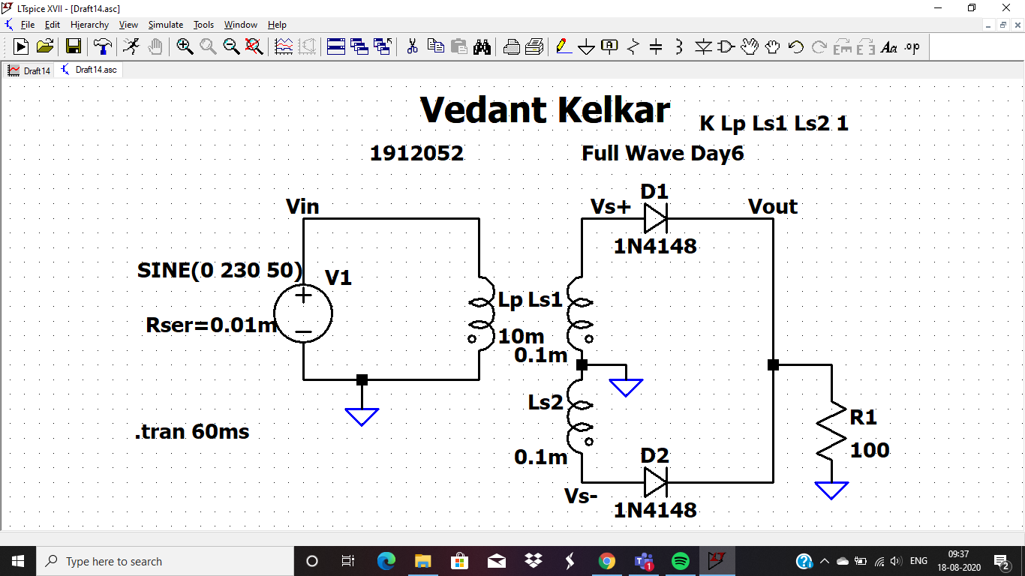

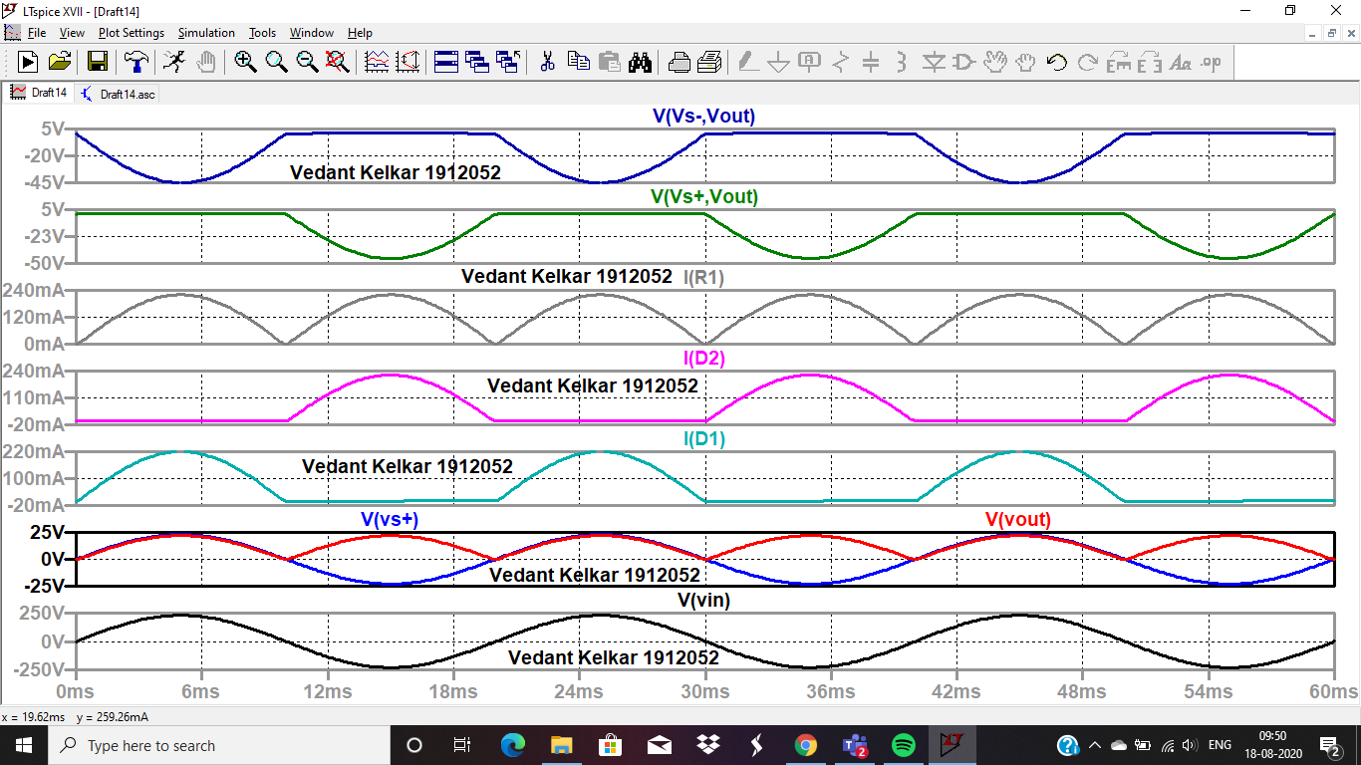

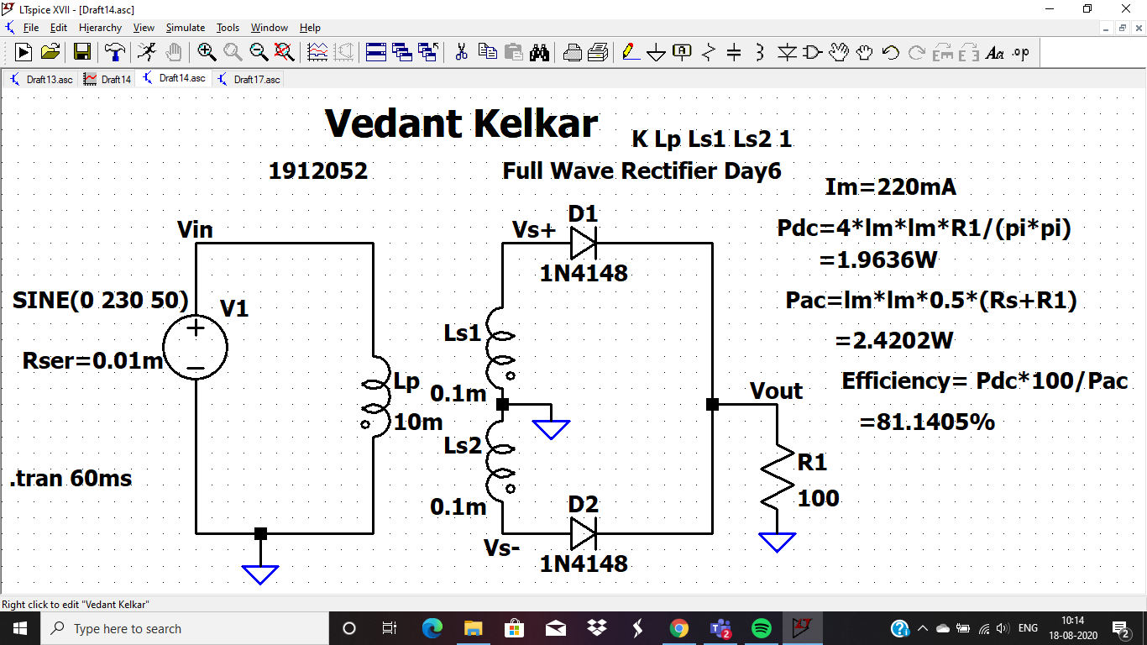

**Im=220mA**

**Pdc= 1.9636W**

**Pac= 2.4202W**

**Efficiency= 81.1405%**

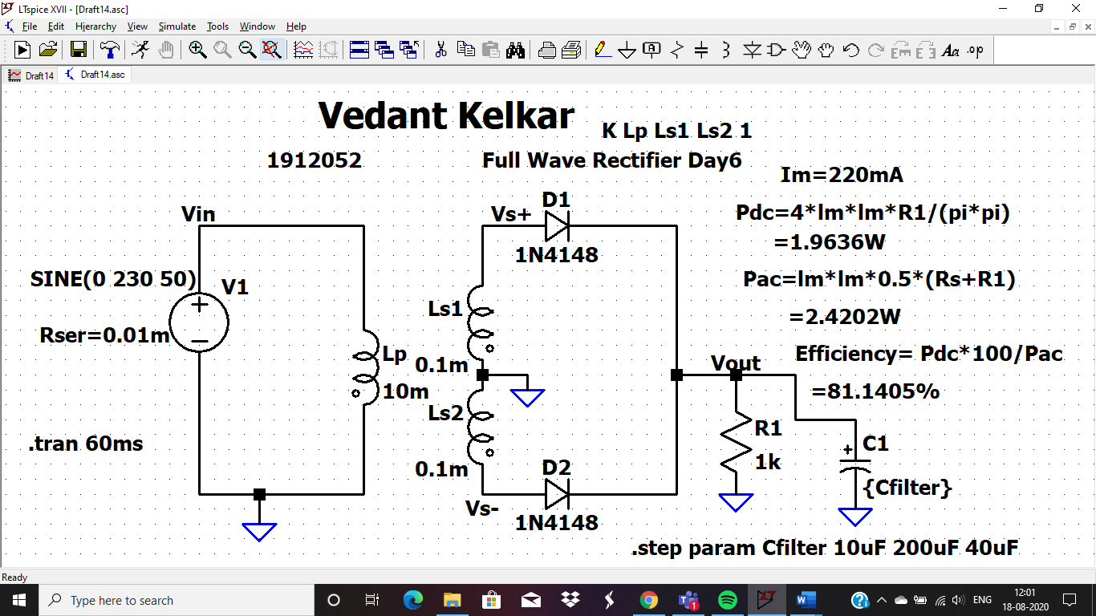

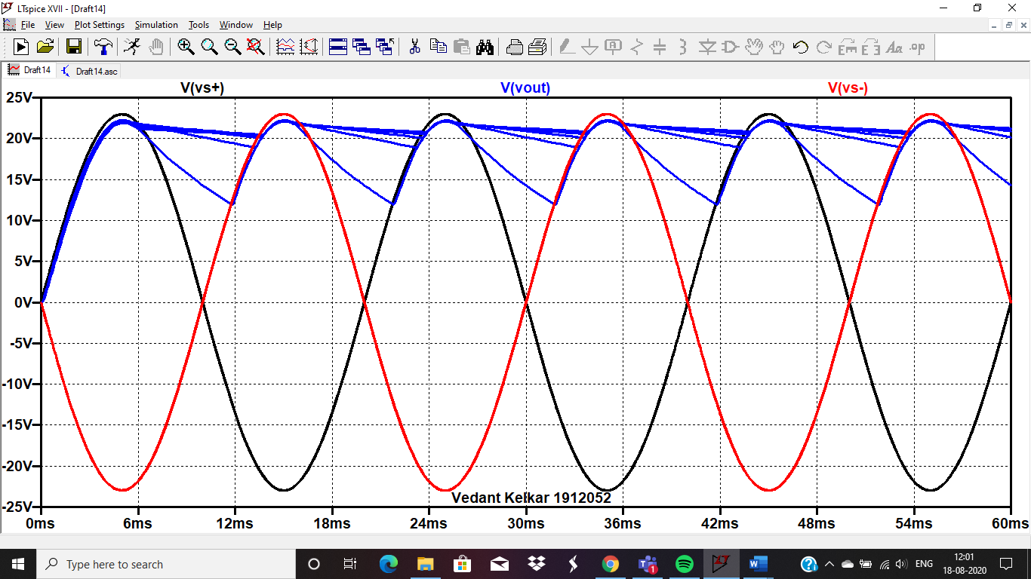

Kindly explain the parametric sweep here for capacitor, and how does it effect the output ?

**I HAVE DONE THE DESIRED THE CHANGES**

**In order to produce a constant DC voltage we need to supress the ripples of a DC voltage. This can be achieved by using a capacitor filter or inductor filter at the output side. In the below circuit we are using the capacitor filter. The capacitor fulter placed at the output side smoothens the pulsating DC to pure DC.**

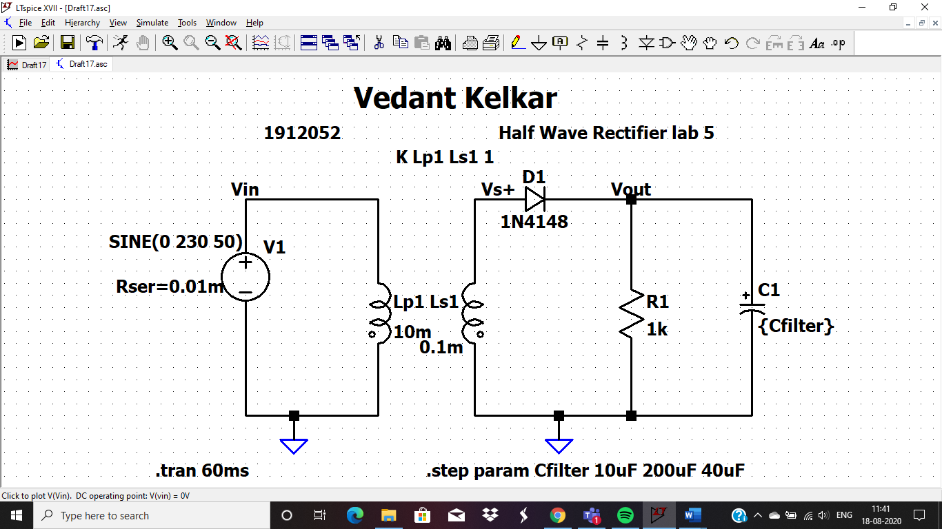

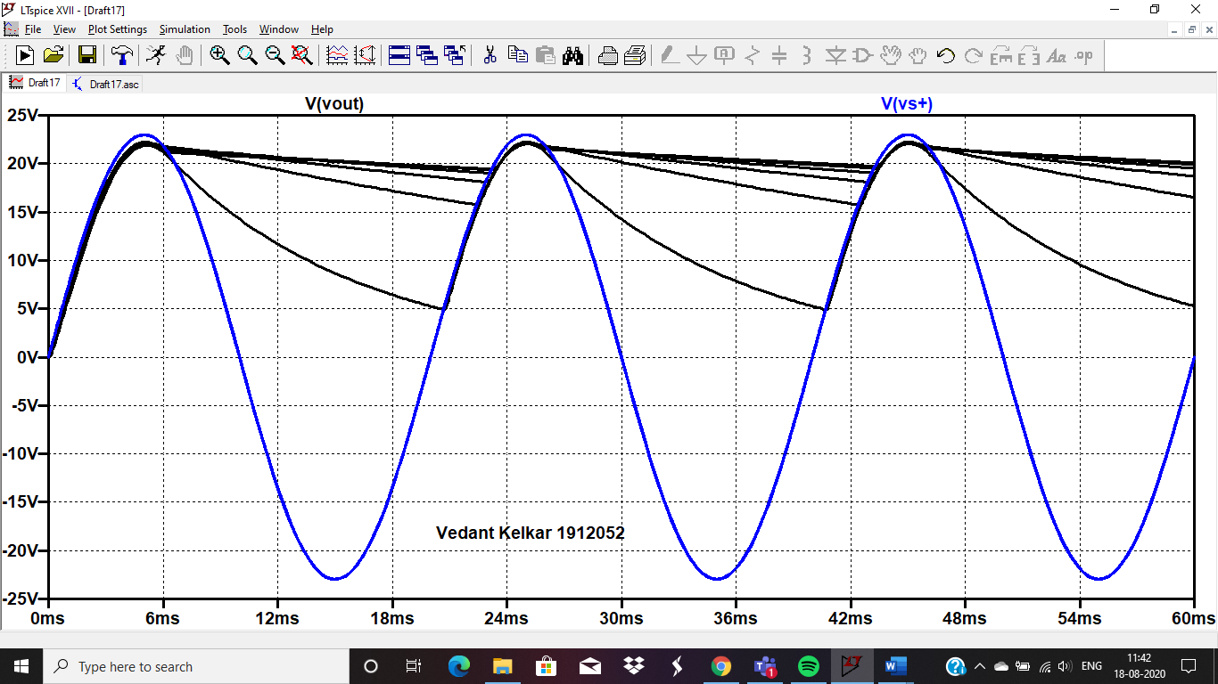

Kindly explain the parametric sweep here for capacitor, and how does it effect the output ?

**AC LAB 6 is approved with suggestions: Inderjit Singh Dhanjal**

**In order to produce a constant DC voltage we need to supress the ripples of a DC voltage. This can be achieved by using a capacitor filter or inductor filter at the output side. In the below circuit we are using the capacitor filter. The capacitor fulter placed at the output side smoothens the pulsating DC to pure DC.**